Pursuant to the powers vested in it under section 10 of the Motorized Snow Vehicles and All-Terrain Vehicles Act, RSNL 1990 c M-20, as amended, and under section 414(2)(s) of the Municipalities Act 1999 SNL 1999, c M-24, as amended, and all other powers it enabling, the Town Council of the Town of Deer Lake, in a session convened on the 11th day of June 2020, hereby passes and enacts the following regulations.

----------------------------------------------- -----------------------------------------------------
Mayor Town Clerk

- These Regulations may be cited as The Town of Deer Lake Recreational Vehicle Regulations.

- For the purpose of these regulations:

  - “All-Terrain Vehicle” means a wheeled motorized vehicle, excluding a two wheeled vehicle, designed or adapted for off-road use, but for purposes of these Regulations does not include a tracked motorized vehicle;

  - “ATV” means an All-Terrain Vehicle;

  - “Council” means the Town Council of the Town of Deer Lake;

  - “Designated Route” means any Highway or Public Pathway approved by Council for use by ATVs or Off-Road Motorcycles, as set out in Schedule “A” to these Regulations;

  - “Enforcement Officer” means a municipal enforcement officer as defined by the Municipalities Act 1999 SNL 1999, c M-24, as amended, or a peace officer as defined by the Highway Traffic Act;

  - “Highway” means a place or way, including a structure forming part of the place or way, designed and intended for, or used by, the public for the passage of traffic or the parking of Motor Vehicles, and includes all the space between the boundary lines of the place or way;

  - “Highway Traffic Act” means the Newfoundland and Labrador Highway Traffic ActRSNL 1990 c. H-3, as amended;

  - “Off-Road Motorcycle” means any two-wheeled motorized vehicle that is being used off-road or is not registered under the Highway Traffic Act, and specifically includes a trail bike.

  - “Operator’s Registered Address” means the address which is identified on the operator’s driver’s license issued under the Highway Traffic Act;

  - “Motor Vehicle” means a motor vehicle registered under the Highway Traffic Act;

  - “Motorized Snow Vehicle” means a tracked vehicle, commonly known as a snowmobile, where the driver sits astride a seat and which is designed for operation over snow covered land and ice;

  - “Motorized Snow Vehicles and All-Terrain Vehicles Act” means the Newfoundland and Labrador Motorized Snow Vehicles and All-Terrain Vehicles Act, RSNL 1990 c M-20, and the regulations thereto, as amended;

  - “Public Pathway” means any pathway or trail assumed under the ownership of the Town of Deer Lake or maintained under the jurisdiction of the Town of Deer Lake;

  - “Town” means the Town of Deer Lake.

- All ATVs, Off-Road Motorcycles and Motorized Snow Vehicles operated in the Town must be operated, registered and insured in accordance with the Motorized Snow Vehicles and All-Terrain Vehicles Act.

- A person shall not operate an ATV, Off-Road Motorcycle or Motorized Snow Vehicle:

  - Without due care and attention or without reasonable consideration for persons or property;

  - In any area designated as a park or playground;

  - On a public pathway;

  - On a sidewalk or designated walking and/or bicycling path;

  - On private property without the express permission of the owner or occupant of the property;

  - On property owned or occupied by a hospital, health centre, school or senior citizens’ home;

  - In any area where signs prohibit the use and operation of an ATV, Off-Road Motorcycle or Motorized Snow Vehicle;

  - In such a manner as to constitute a nuisance or create annoyance to residents or other persons;

  - In such a manner as to be hazardous to himself/herself or to other persons or property; or

  - In such a manner as to harass, chase, run over, injure or kill any wildlife or domestic animal(s).

- A person shall not drive an ATV, Off-Road Motorcycle or Motorized Snow Vehicle upon a Highway unless:

  - The person is the holder of a class of driver’s license issued under the Highway Traffic Act; and

  - In the case of a driver who is less than 19 years of age, the ATV, Off-Road Motorcycle or Motorized Snow Vehicle is insured as required by the Motorized Snow Vehicles and All-Terrain Vehicles Act.

- A person shall not drive, operate or otherwise move an ATV, Off-Road Motorcycle or Motorized Snow Vehicle upon a Highway except in accordance with this Section 6:
  - A person may drive, operate or move a vehicle across a Highway only at those points where the driver has not less than 100 meters visibility in both directions along the Highway; and
  - A person may drive, operate or move an ATV, Off-Road Motorcycle or Motorized Snow Vehicle along a Highway only when by reason of storm or blizzard the Highway is incapable of being used by Highway motor vehicles, but not so as to interfere with snow clearing or other operations being carried out on that portion of the Highway.
- Notwithstanding Sections 5 and 6, a person may drive, operate or otherwise move an ATV or Off-Road Motorcycle upon a Designated Route, provided that:

  - Notwithstanding Sections 10 and 11 of these Regulations, that person is at least 16 years of age, and the holder of a class of driver’s license issued under the Highway Traffic Act;
  - That person or the ATV or Off-Road Motorcycle carries a liability insurance policy and proof thereof can be readily produced;
  - the ATV has affixed toand clearly exposed on each side of that vehicle in a conspicuous position at or toward the front of the vehicle the numbered plates or decals issued under the Motorized Snow Vehicles and All-Terrain Vehicles Act;
  - The ATV or Off-Road Motorcycle is equipped with an exhaust system that is of the original equipment manufacturer, is in working order, has not been modified to increase sound, and is operated in a manner to prevent excessive or unusual noise;
  - That person or the ATV or Off-Road Motorcycle does not at any time exceed any posted speed limit, and in any event, does not at any time exceed a speed greater than 40 kilometers per hour, and not greater than 20 kilometers per hour off of Designated Routes;
  - That person at all times yields the right of way to drivers of all other classes of Motor Vehicles;
  - That person adheres to the “rules of the road”, as described in Part V of the Highway Traffic Act, or any similar successor legislation;
  - That person does not operate an ATV or Off-Road Motorcycle on a Designated Route before May 15th or after November 30th of any year;
  - That person does not operate an ATV or Off-Road Motorcycle on a Designated Route earlier than 0700 or later than 2200 on any day; and
  - That person at all times complies with all other provisions of these Regulations.

- Notwithstanding Sections 5 and 6, a person may drive, operate or otherwise move an ATV or Off-Road Motorcycle upon a Highway which is not a Designated Route provided that:

  - The Highway in use connects the operator’s registered address with the closest Designated Route; or

  - Prior written permission has been obtained from the Town.
- A person under 13 years shall not operate a Motorized Snow Vehicle in the Town, and no one shall cause or permit a person under the age of 13 years to drive a Motorized Snow Vehicle in the Town, unless the person is accompanied by another person who is 19 years of age or older.
- A person under the age of 16 years shall not operate an ATV in the Town, unless:
  - The person is at least 14 years of age and operating an ATV with an engine size of 90 cc or less; and
  - The person is accompanied by a person who is at least 19 years of age.
- For the purposes of Sections 9 and 10, “accompanied” means that the person has visual and voice communication with the operator.
- Council may erect warning, cautionary, directional, limiting or prohibiting signs as to the operation of ATVs, Off-Road Motorcycles and Motorized Snow Vehicles, and the operator of any ATV, Off-Road Motorcycle or Motorized Snow Vehicle who fails to obey such signs is guilty of an offence under these Regulations.

- A person who contravenes or fails to comply with these Regulations is upon summary conviction guilty of an offence and is liable:

  - For a first offence, to a fine between the minimum and maximum outlined in Schedule “B” of these Regulations, or a term of imprisonment of not more than one month or to both the fine and the imprisonment; and

  - For a second or subsequent offence, to a fine between double the minimum and maximum outlined in Schedule “B” of these regulations, or to a term of imprisonment of not more than three months, or to both the fine and the imprisonment.

- These Regulations do not apply to vehicles owned and operated by Council or those operated by emergency or enforcement services, or any other persons who are exempt by the provisions of the Motorized Snow Vehicles and All-Terrain Vehicles Regulations.

- These Regulations include the Schedules attached to them, and the Schedules are hereby declared to form part of these Regulations.

- If a court of competent jurisdiction should declare any section or part of a section of these Regulations to be invalid, such section or part of a section shall not be construed as having persuaded or influenced Council to pass the remainder of the Regulations and it is hereby declared that the remainder of the Regulations shall be valid and shall remain in force.

- These regulations shall come into force as of the date enacted by Council.
Schedule “A”
Designated Routes
- Goose Arm Road
- George Aaron Drive, from Nicholsville Bridge to Goose Arm Road
- Nicholsville Road
- T’Railway

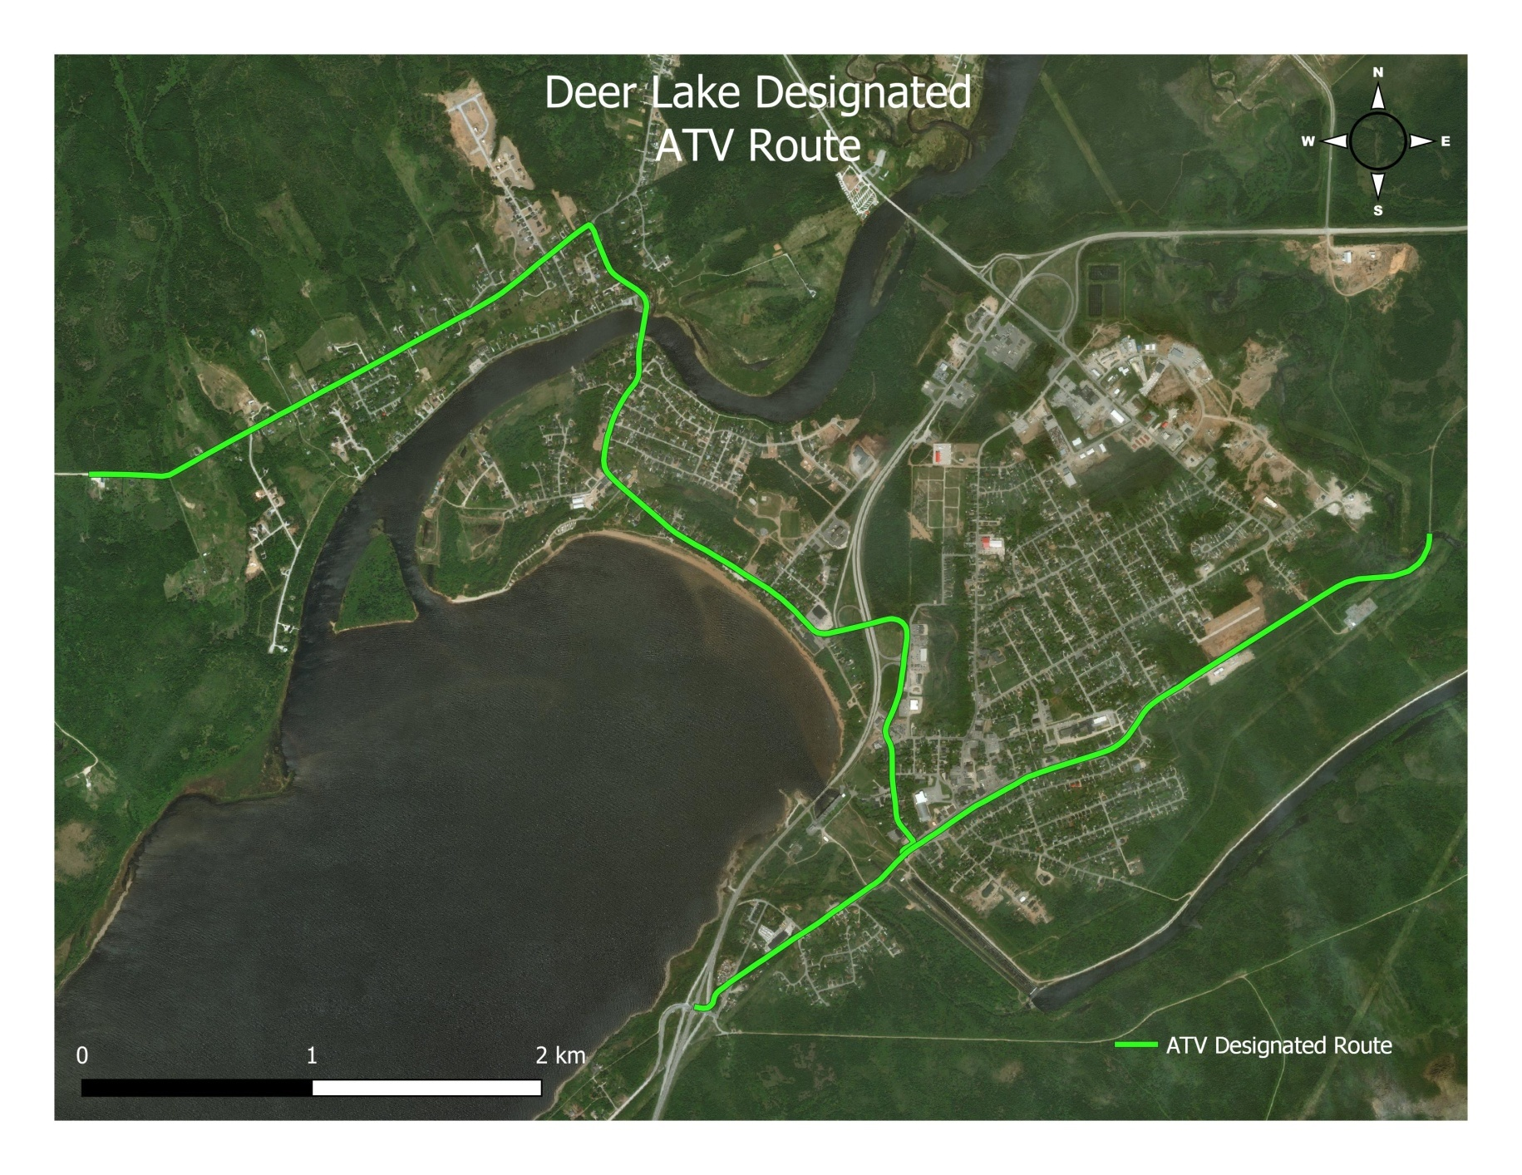

Schedule “B”
Schedule of Fines
Regulation | Offence | Minimum Fine | Maximum Fine
4. | Operating an ATV off of designated route which is not directly between designated route and  registered address of ATV without written permission from the town | $100.00 | $150.00
5. (a) | Operating an ATV under the age of 16 | $150.00 | $225.00
5. (b) | Operating an ATV without a driver’s license issued under the Highway Traffic Act | $150.00 | $225.00
5. (c) | Operating an ATV without proof of a liability insurance policy | $400.00 | $500.00
5. (d) | Operating an unregistered ATV | $150.00 | $225.00
5. (e) | Operating an ATV without numbered plates or decals affixed as described in these regulations | $150.00 | $225.00
5. (f) | Operating an ATV without a working exhaust system of the original equipment manufacturer | $100.00 | $150.00
5. (g) | Operating an ATV at speeds which exceed the maximum outlined in these regulations | $150.00 | $225.00
6. | Failing to adhere to the “rules of the road” as described in Part V of the Newfoundland and Labrador Highway Traffic Act or any similar or successor legislation. | $150.00 | $225.00
7. | Operating an ATV on a highway after council has closed the route for the winter season each year. | $150.00 | $225.00
8. | Operating an ATV before 0700 and after 2200 | $150.00 | $225.00
9. | Disobeying signs which have been erected by Council | $150.00 | $225.00

